CIS 485 – Abusive Workplace Interactive Ethics Scenario
Group 6
Date: October 2025
Team Members:
- Megan Van Luyn – Project Manager
- Komalpreet Kaur – Graphic Designer
- Adakole Jumbo-Ochigbo – Documentation Lead
- Mehak Gupta – Game Designer
- Garv Singh Saini – Quality Assurance Lead

1. Introduction
This report documents the design, ethical framework, and development process of Abusive Workplace, an interactive digital scenario created by CIS 485 Group 6 using Twine, a non-linear storytelling tool widely used for narrative simulations.
The project transforms the written ACM Code of Ethics case study: “Abusive Workplace Behavior” into a dynamic, decision-driven learning experience. By adapting a real-world ethical dilemma into an interactive medium, the team sought to create an engaging, reflective environment that goes beyond reading about ethics. It allows players to experience the emotional and professional consequences of their actions.
At its core, the project explores how computing professionals can uphold ethical standards when faced with workplace harassment, intimidation, or disrespect. The narrative positions the player as an employee confronted by abusive behavior from a colleague. Through a series of branching decisions, players are challenged to respond to escalating tension, balancing professionalism, empathy, and self-respect. Each choice leads to a different outcome which range from cycles of ongoing abuse to positive organizational change and can illustrate how individual decisions can either perpetuate or resolve workplace conflict.
The scenario also demonstrates how interactive storytelling can support ethical education. Unlike traditional case studies that present a single outcome, Twine’s branching structure enables users to explore multiple perspectives, helping them see how different responses affect both personal well-being and team culture. This experiential design aligns with the ACM Code of Ethics’ emphasis on integrity, fairness, and respect in professional settings, while reinforcing the importance of courage and communication in addressing unethical behavior.
From a technical perspective, the project integrates narrative logic, interface design, and simple algorithmic structures to simulate realistic moral decision-making. Every passage and hyperlink in the Twine story represents a potential ethical pathway — effectively turning the narrative into a moral decision tree. This blending of technical storytelling and ethical reasoning makes the project a practical demonstration of how computing tools can be leveraged for social good, education, and professional growth.
Finally, Abusive Workplace serves as both a digital artifact and a reflection exercise for future professionals. It reminds players that ethical conduct is not abstract but embodied in everyday choices and how we communicate, support colleagues, and confront harmful behavior. Through this interactive medium, the team emphasizes that maintaining an ethical workplace culture begins with individual action supported by shared accountability.

2. Project Objectives
The goals of the project were to:
- Translate the ACM case study into a branching interactive narrative to promote ethical reflection.
- Demonstrate how AI-assisted tools and collaborative software development practices can support ethical storytelling.
- Model the impact of decisions on workplace culture, safety, and accountability.
- Strengthen group collaboration and professional communication under defined roles and policies.

3. Source Material and Ethical Context
The Abusive Workplace project is based on the ACM Code of Ethics case study: “Abusive Workplace Behavior.” This case describes a professional setting where disrespectful communication and power imbalances go unchecked, raising important questions about how employees should respond when they witness or experience mistreatment. By adapting this story into an interactive format, the project helps players think about moral courage and professional responsibility in a realistic way.
The original case highlights common issues in toxic work environments, such as fear of speaking up, lack of support from management, and the normalization of bad behavior. The team used these ideas to create a story that shows how individual choices can either allow abuse to continue or lead to positive change.
Ethical Issues Explored
- Respect and Integrity:
Players are encouraged to consider how they would react to being disrespected or verbally attacked at work. The story shows the importance of staying calm and professional while still standing up for oneself.
- Duty to Report:
The scenario raises the question of whether employees should speak up or report incidents they witness. It shows how staying silent can make the situation worse, while taking action can protect others and improve the workplace.
- Power and Accountability:
The project explores how authority and fear of consequences can affect ethical decisions. It reminds players that everyone shares some responsibility for maintaining fairness and respect, no matter their position.
- Workplace Culture:
The story emphasizes how silence can normalize abuse. It encourages open communication and teamwork as key steps in building a healthier and more supportive workplace.
4. Alignment with the Abusive Workplace Case Study
The Abusive Workplace Behavior case study from the ACM Code of Ethics emphasizes fairness, respect, and accountability in professional settings. Our interactive storyline builds on these same ideas by recreating similar challenges that test workplace ethics and professional conduct.
- Workplace Respect:
The player faces moments where communication and professionalism are tested, showing how disrespectful behavior can quickly create a hostile environment if left unaddressed.
- Fairness and Credit:
The scenario mirrors situations where individuals’ contributions are overlooked or dismissed, reinforcing the ethical duty to recognize others’ work and treat colleagues fairly.
- Leadership Accountability:
The story includes different leadership responses—some supportive, others dismissive—to show how managers and supervisors influence the organization’s ethical culture. This reflects the case study’s concern about the damage caused by managerial neglect.
- Public Good vs. Corporate Pressure:
In the final branch, players must decide whether the company should focus on maximizing profit or supporting charity work. This choice captures the tension between organizational success and social responsibility, a key theme in many workplace ethics cases.

5. Ethical Analysis (ACM Code Alignment)
Scenario Decision | Related ACM Principle | Description
Ignoring the researcher | 1.2 – Avoid harm, 1.3 – Be honest and trustworthy | Failing to act on a reported vulnerability shows a lack of integrity and concern for public welfare.
Acting outside authority | 2.3 – Respect existing rules, 2.6 – Perform only in areas of competence | Taking unauthorized action, even with good intent, can cause harm and demonstrates poor professional judgment.
Reporting properly | 2.5 – Provide thorough evaluations, 3.1 – Ensure public good | Proper escalation and communication reflect responsible and ethical conduct.
Focusing on profit | 1.1 – Contribute to society and human well-being | Prioritizing wealth over accessibility ignores the broader ethical duty to serve society.
Focusing on charity | 1.1 – Contribute to society and human well-being | Supporting charitable efforts promotes fairness, inclusivity, and a positive social impact.

6. System Design Overview
Tools and Technologies
- Twine (v2.0) – Used for story creation and branching logic.
- HTML Export – Final story playable in any web browser.
- GitHub Repository – Version control and collaboration platform:
https://github.com/CanadianLuyn/CIS485_Group-6
- Brightspace / Docsify – Used for displaying instructions and documentation.
Narrative Logic
- Inputs: Player choices determine story direction.
- Algorithm: Twine’s story nodes manage conditional logic linking one passage to another.
- Outputs: Narrative outcomes reflect ethical and emotional consequences.

7. Storyline Summary
In Abusive Workplace, the player takes on the role of an employee who experiences verbal abuse from a coworker. Throughout the story, the player must decide how to respond to the situation. Each choice leads to a different outcome, showing how communication, silence, and teamwork can shape the workplace environment.
Main Decision Paths
- Stay calm and explain your work – Encourages open communication and professionalism.
- Ignore the abuse and continue working – Allows the situation to persist and may lead to the Cycle of Abuse.
- Encourage coworkers to intervene – Promotes teamwork and often leads to Positive Change.
- Pretend everything is fine – Avoids confrontation but results in continued harm and tension.
Outcomes
- Cycle of Abuse: Mistreatment continues because no one speaks up.
- Partial Resolution: Some improvement occurs, but underlying issues remain.
- Positive Change: The workplace improves through cooperation and accountability.
The story ends with a Restart option, inviting players to reflect on their decisions and explore different paths. This replay feature reinforces the idea that ethical choices can always be reconsidered and improved upon.

8. Flowchart and Story Architecture
The flowchart visualizes story branching and end states:
- Decision Nodes: Represent user choices.
- Paths: Arrows showing cause-effect relationships between decisions and outcomes.
- Terminal States: Reflect the ethical and organizational results of the player’s behavior.
This structure ensures logical consistency and reinforces the learning objective: ethical choices have systemic consequences.
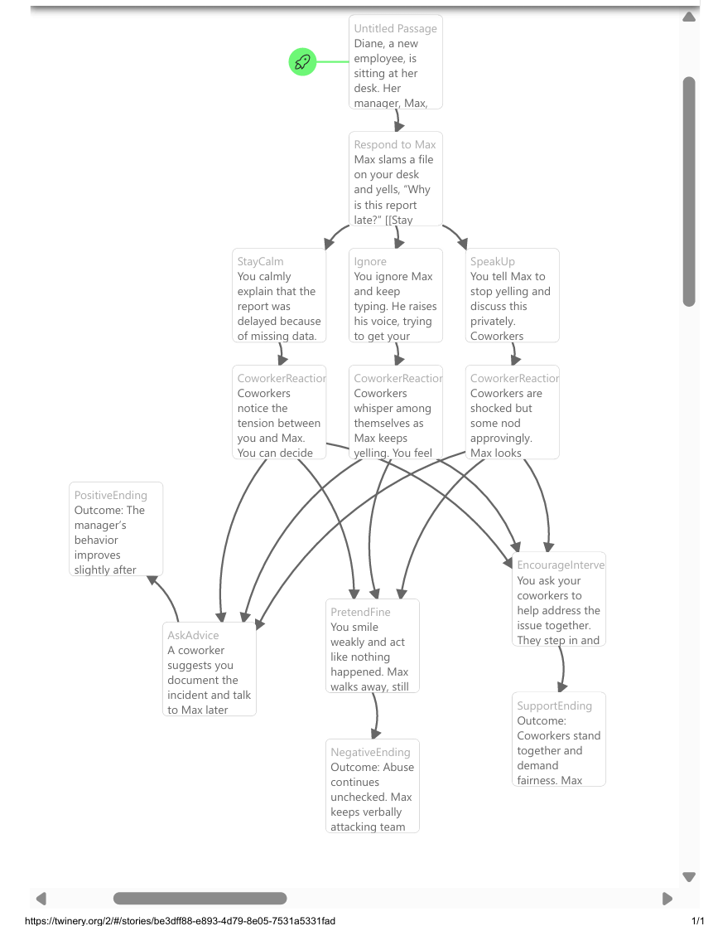

9 Group Roles and Collaboration
Member | Primary Role | Secondary Role / Focus
Megan Van Luyn | Software Developer | Project Manager / Instructor Liaison
Komalpreet Kaur | Software Developer | Graphic Designer
Adakole Jumbo-Ochigbo | Software Developer | Documentation Lead
Mehak Gupta | Software Developer | Game Designer
Garv Singh Saini | Software Developer | Quality Assurance Lead
Collaboration Methods
- Communication: WhatsApp (daily updates), Zoom (weekly meetings).
- Scheduling: Async Tuesdays during class time.
- Progress Tracking: Gantt chart, weekly reports, Excel task checklist.
- Decision-Making: Majority vote; anonymous vote or coin flip for deadlocks.
- Quality Control: Each submission undergoes two draft reviews before finalization.

10. AI Usage and Ethical Compliance
Per the Group AI Usage Policy, the team used AI tools responsibly to assist brainstorming and drafting, not to replace original work.
- Tools permitted: GitHub Copilot, ChatGPT, DeepSeek.
- All AI contributions were disclosed and reviewed for accuracy.
- AI outputs were validated through manual review and testing by the responsible member.
This process ensured alignment with UFV’s academic integrity standards and ethical guidelines in computing.
Date | Milestone | Description | Status
Nov 17 | Story draft completed | Megan uploaded the first storyline draft for review. | ✅ Completed
Nov 25 | Game prototype and graphics ready | Mehak and Komal finalized visuals and integrated the Twine framework. | ✅ Completed
Nov 20 | Review and testing | Garv reviewed the storyline and provided feedback on flow and ethical logic. | ✅ Completed
Nov 29 | Documentation finalized | Adakole compiled the final report, ethical mapping, and milestone summaries. | ✅ Completed
Nov 30 | Submission | Full project submitted through the course portal. | ⏳ Pending

11. Gameplay Evidence

📍 Screenshot 1 – Opening Scene
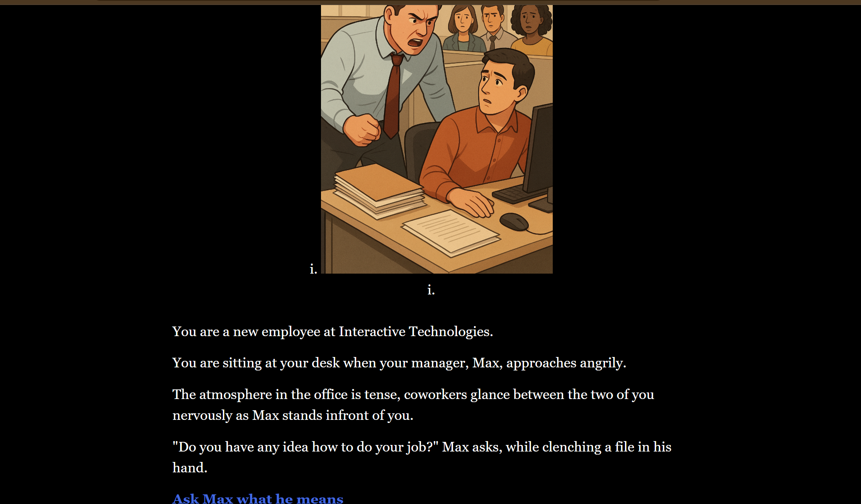
📍 Screenshot 2 – First Major Decision Point
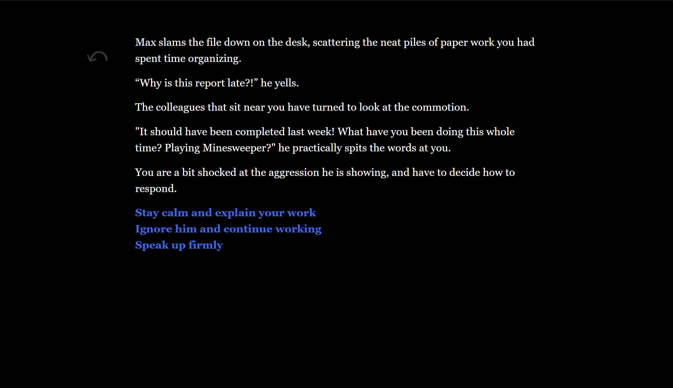
📍 Screenshot 3 – Coworker Observation
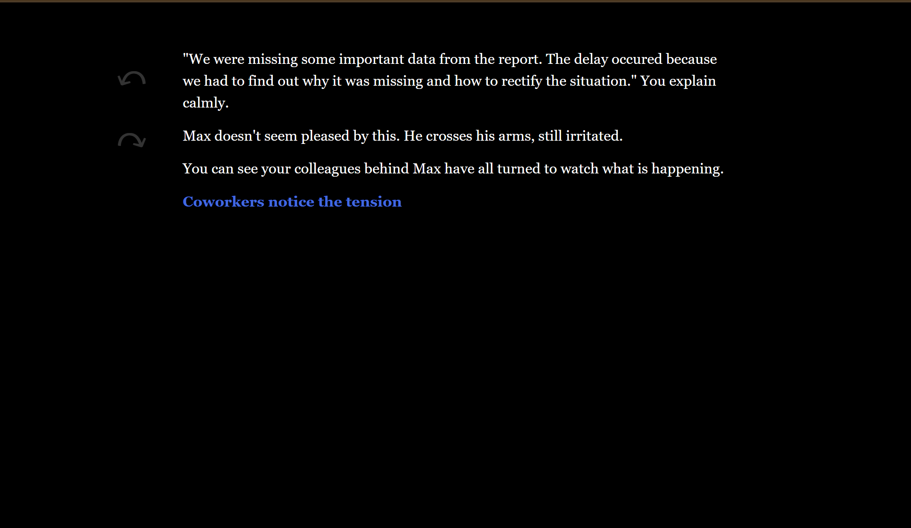
📍 Screenshot 4 – HR Reporting Path
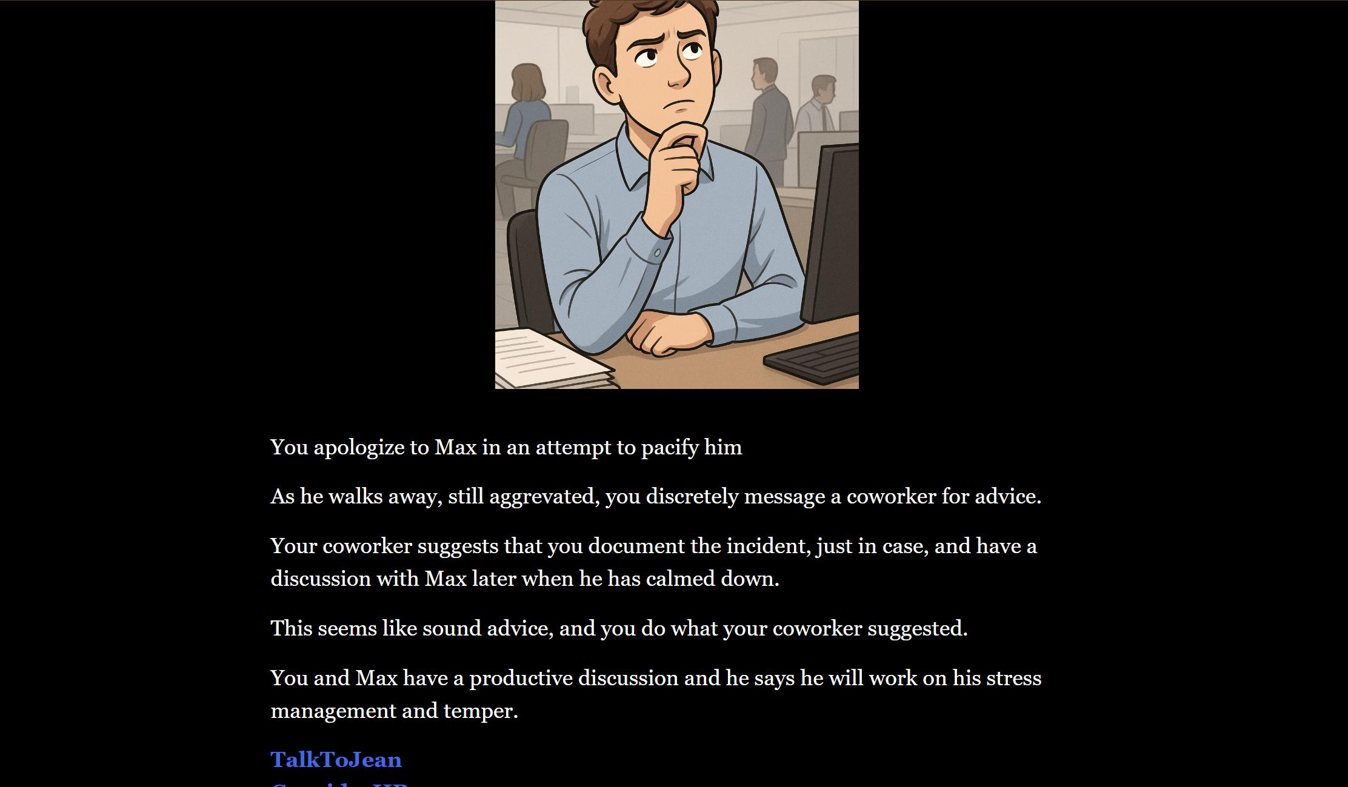
📍 Screenshot 5 – Ending Example
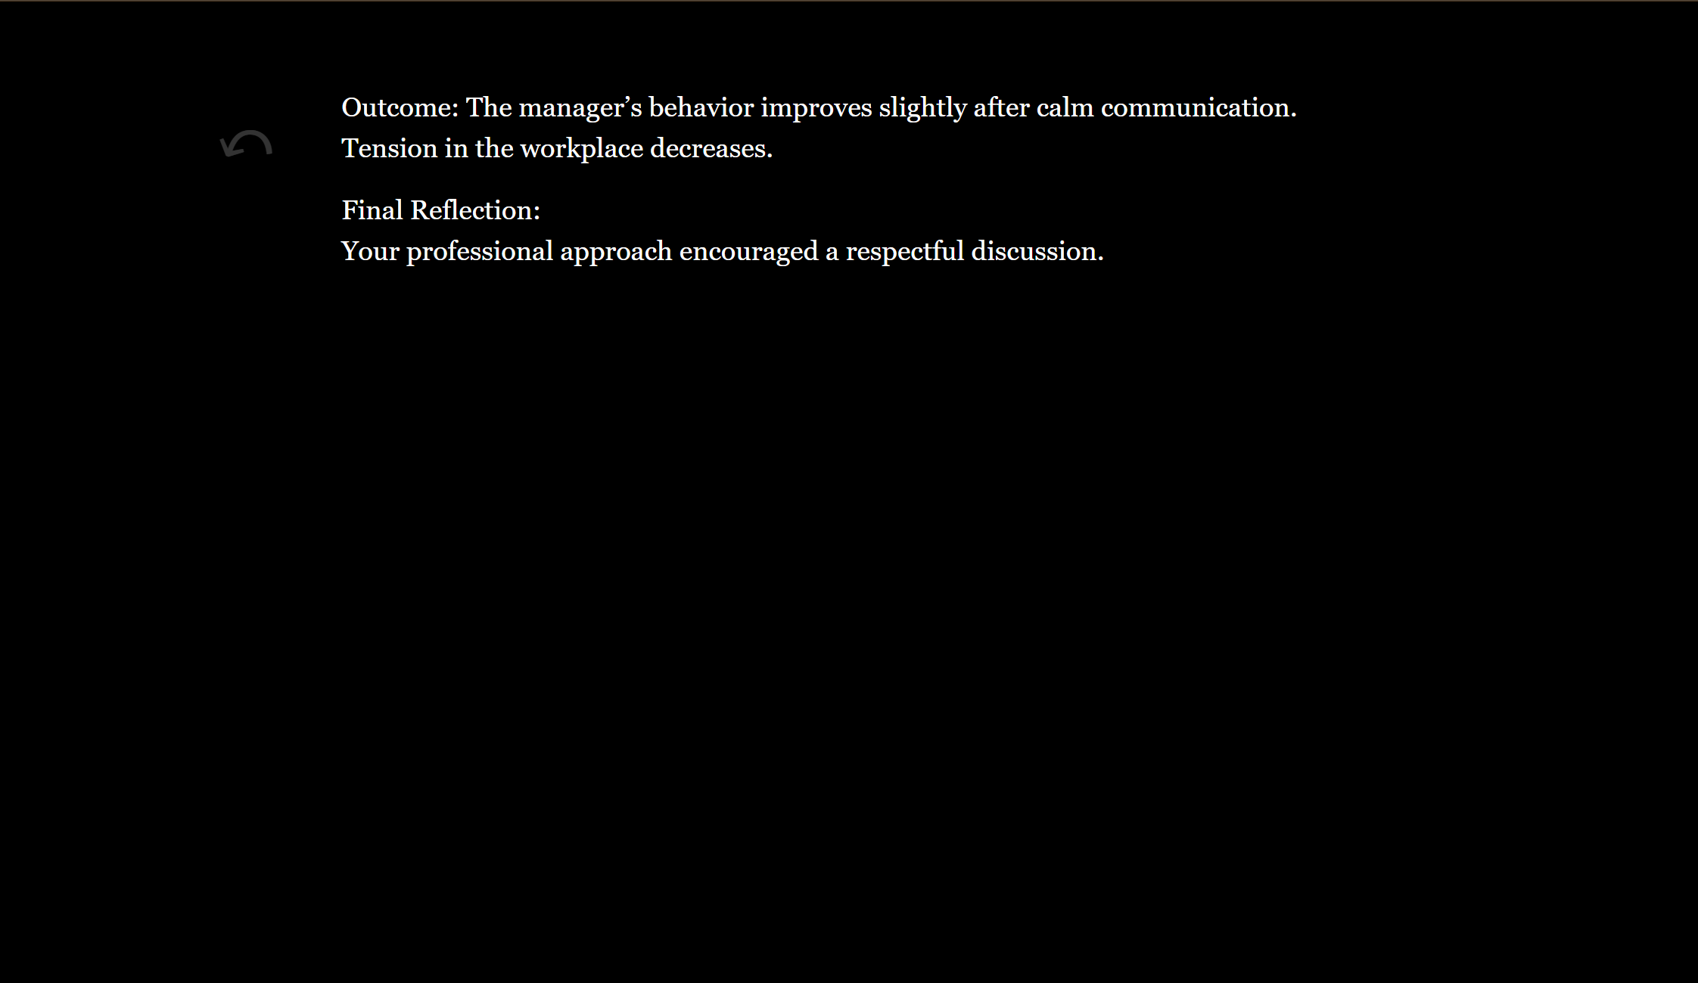

12. Reflection on Peer Feedback (Required Section)
The peer feedback provided valuable insight into the narrative structure, ethical clarity, and user experience.
Positive Feedback Received
Peers appreciated:
- Realistic and emotionally grounded dialogue
- A relatable and authentic storyline
- The opening image and polished presentation
- Clear and intuitive decision pathways
- Strong emotional engagement
Example comments included:
- “The story felt realistic and captured real workplace tension.”
- “I loved the opening image and the book-like storytelling.”
- “The choices felt meaningful and the ethical dilemmas were clear.”
Challenges Identified by Peers
Many players described the hardest choices as:
- Whether to stay calm or speak up
- Whether to ask a coworker for advice or stay silent
- Whether to report to HR or confront the manager directly
These reflect genuine ethical dilemmas, mirroring real workplace complexity.
Suggestions for Improvement
Key suggestions included:
- Add more intermediate choices or additional story branches
- Raise narrative stakes and consequences
- Consider giving more background on characters
- Avoid overly repetitive endings where “nothing changes”
Changes Implemented
Based on feedback, we:
✔ Expanded the coworker-interaction path
✔ Added more nuanced consequences for decisions
✔ Enhanced clarity in endings by linking them to specific ACM principles
✔ Improved pacing and emotional transitions
✔ Refined dialogue choices for realism
✔ Strengthened the HR intervention arc
Feedback We Did Not Implement (and Why)
- Some peers found unsatisfying the endings where abuse continues. We kept them intentionally to reflect the real-world risk of inaction.
- Requests for additional media (audio, animations) could not be added due to Twine’s limitations and accessibility requirements.
- Adding extensive backstory was limited by time and the scope of the assignment.

13. Running the Project
How to Play
- Clone or download the repository:
- git clone https://github.com/CanadianLuyn/CIS485_Group-6.git
- Navigate to the directory:
CIS485_Group-6/
- Open any version of the story (e.g., Abusive Workplace 3.1.html) in a browser.
- Click through the dialogue choices to explore the ethical outcomes.
Requirements
- No installation required.
- Works on any device with a modern web browser.

14. Reflection and Learning Outcomes
Through this project, the team showed strong collaboration and growth in several key areas:
- Ethical Awareness: Turning workplace ethics into an interactive story helped the team and players better understand moral responsibility and the real impact of everyday choices.
- Technical Skills: Using Twine for story design and GitHub for version control strengthened the group’s ability to plan, build, and manage a structured digital project.
- Teamwork and Leadership: Members took on specific roles, shared feedback, and stayed organized through consistent communication and task management.
- AI Literacy: The group used AI tools responsibly, reviewing all generated content for accuracy and making sure that its use was transparent and ethical.
Each story path was designed to connect ethical principles—such as duty, consequence, and virtue—with realistic workplace behavior. The result is a project that blends ethical reflection with practical decision-making, showing how technology can be used to teach professional integrity in a meaningful way.

15. Conclusion
The Abusive Workplace project successfully merges ethical reflection with interactive media design.
By turning a written case study into a playable experience, the team transformed abstract ethical guidelines into a relatable, experiential format that invites users to think critically about workplace culture and moral courage.
The project also demonstrates how collaborative processes, responsible AI use, and open-source development tools can foster ethical innovation in computing education.

16. References
- Association for Computing Machinery (ACM). Abusive Workplace Behavior – ACM Code of Ethics Case Study. Retrieved from https://www.acm.org/code-of-ethics/case-studies/abusive-workplace-behavior
- Twine Documentation: Creating Interactive Stories. Retrieved from https://twinery.org
- University of the Fraser Valley. CIS 485 Project Guidelines and Group Contract Template.
- CIS 485 Group 6 GitHub Repository: https://github.com/CanadianLuyn/CIS485_Group-6

